
Rev | Date | Author | Description
A | 2026-04-08 | AJ | Initial draft
B | 2026-07-23 | AJ | Adjust for UART instead of I2C
ECP Protocol Specification
This document is the exclusive property of Data Panel Corporation. Any reproduction or this document without permission is prohibited.
Contents
1 Introduction 2
2 Physical layer 3
2.1 Request/Response cycle 3
2.2 I²C bus 4
2.3 Other buses 5
3 Data link layer 5
3.1 Request header 5
3.2 Response Header 6
3.2.1 Result codes 6
3.3 data: Payload 7
3.4 data_crc: Payload CRC 7
4 Network layer 8
4.1 Unconfigured state 8
4.2 Active state 8
4.3 Enumeration and addressing 8
5 Application layer 10
5.1 Host operation 10
5.2 ECP operation 11
6 Commands 12
6.1 Command 0x0000: ECP_CMD_PROTO_VERSION 12
6.2 Command 0x0001: ECP_CMD_IDENT 13
6.3 Command 0x0002: ECP_CMD_ENUM 13
6.4 Command 0x0003: ECP_CMD_HELLO 14
6.5 Command 0x0004: ECP_CMD_ECHO 14
6.6 Command 0x0005: ECP_CMD_REBOOT 14
6.7 Command 0x0006: ECP_CMD_FEATURES 15
6.8 Command 0x0007: ECP_CMD_DEVICE_EVENT 15
6.9 Command 0x0008: ECP_CMD_ESTOP 16
6.10 Command 0x0009: ECP_CMD_BOOT_JUMP 16
6.11 Command 0x1000: ECP_CMD_IO_READ 17
6.12 Command 0x1001: ECP_CMD_IO_WRITE 18
6.13 Command 0x1002: ECP_CMD_IO_GET_ATTRIB 18
6.14 Command 0x1003: ECP_CMD_IO_SET_ATTRIB 19
6.15 Command 0x1100: ECP_CMD_LED_COLOR 19
6.16 Command 0x1101: ECP_CMD_LED_BRIGHTNESS 20
6.17 Command 0x1200: ECP_CMD_GPIO_CONFIG 20
6.18 Command 0x1201: ECP_CMD_GPIO 20
6.19 Command 0xFF00: ECP_CMD_PEEK 21
6.20 Command 0xFF01: ECP_CMD_POKE 22
6.21 Command 0xFF02: ECP_CMD_COMM_STATS 22
6.22 Command 0xFF03: ECP_CMD_UPTIME 22
7 Features 23
7.1 ECP_FEATURE_CH_IO 23
7.2 ECP_FEATURE_PEEK_POKE 23
7.3 ECP_FEATURE_GPIO 23
7.4 ECP_FEATURE_DEVICE_EVENT 24
7.5 ECP_FEATURE_COMM_STATS 24
7.6 ECP_FEATURE_LED 24
8 Reference 25
8.1 DPPort attributes 25

Introduction
The Embedded Co-Processor (ECP) protocol is a proprietary protocol designed to enable intra-board communication over a serial connection between a primary MCU (the host) and one or more I/O co-processors (ECP). The protocol aims to achieve the following goals:
- Accommodate new features without breaking backward compatibility
- Be as simple as possible without needlessly sacrificing flexibility
- Work well over I²C, but allow for other physical layers
- Support automatic identification and enumeration of ECPs and their features
- Allow at least 16 ECPs to be connected to a single host
The following assumptions are made:
- ECPs are connected to no more than one host at a time.
- The host MCU can individually reset each ECP
- The host MCU has configuration-related information that the ECP does needs but does not have access to
This document does not describe the bootloader protocol used to load firmware onto the ECP. For STM32-based ECPs over I²C, see ST Application Note AN4221: I2C protocol used in the STM32 bootloader.
The key words “MUST”, “MUST NOT”, “REQUIRED”, “SHALL”, “SHALL NOT”,“SHOULD”, “SHOULD NOT”, “RECOMMENDED”, “MAY” and “OPTIONAL” in this document are to be interpreted as described in RFC-2119.

Physical layer
The primary physical layer for the ECP protocol is a UART. ECPs MUST support communication at speeds of at least 1 Mbps.
An alternate I²C physical layer was evaluated, but may cause latency problems with many ECPs. If using I²C, all devices MUST support Fast Mode+ at up to 1 Mbit/sec.

Request/Response cycle
Each request/response cycle consists of a request message containing a command and a response from the corresponding ECP. Both the request and response include optional data. The request is an I²C write transaction, and the response is an I²C read transaction, regardless of the direction of the flow of data. A request with no response is an incomplete transaction.
The host MAY interleave transactions to different ECPs such that multiple transactions are pending at a time.
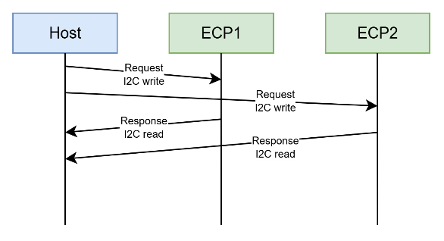
Figure 1:Interleaved transactions
Hosts MUST keep track of all pending requests they submit to ECPs until the response is successfully received by the host. ECPs MUST keep track of transactions directed at their configured address, but can ignore all other I²C traffic.

UART
During the request the host transmits data to the ECP and the ECP receives data.
For the response, the roles are reversed and the ECP transmits data to the host.
The ECP SHOULD NOT transmit data to the host except as a response to a request.

I²C bus
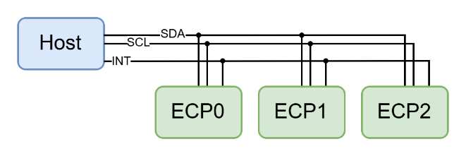
Figure 2: Simple ECP network
The host acts as I²C bus master, and the ECP acts as the slave device. Each request/response cycle consists of two I²C transactions: an I²C write from the host to the ECP (the request), and an I²C read (host reading from ECP).
As the bus master, the host initiates all transactions including requests and responses. Because ECPs must not initiate transactions they have no means of contacting the host asynchronously. Thus, ECPs SHOULD provide an out-of-band mechanism to indicate a need for service to the host, such as an interrupt GPIO. The interrupt line MAY be shared among several ECPs if required. The host can then query each ECP to determine required actions.
The two parts of the transaction SHOULD separated by a STOP condition or alternatively, a repeated START condition MAY be used.
Figure 3: Request I2C transaction, Host → ECP
Figure 4: Response I2C transaction, ECP → Host
ECPs MUST NOT block transactions while a request is being processed, for example by pulling SCL low (“clock stretching”). Instead, ECPs MUST process requests in the background. Long-running commands may need additional time to complete. The ECP SHOULD provide a temporary response indicating that the command is being processed, but is not yet complete. Once complete, the ECP SHALL prepare a response message to be read by the host.
If the host attempts to read data beyond the end of the prepared response message, the ECP SHALL return a NULL byte (0x00) for each byte read.
The ECP SHALL discard any bytes received beyond the length indicated by the header. If the request header is invalid, the ECP SHALL ignore all subsequent bytes received until transaction is complete.

Other buses
The protocol design may be adapted to other physical layers such as SPI. This document does not address such use cases.

Data link layer
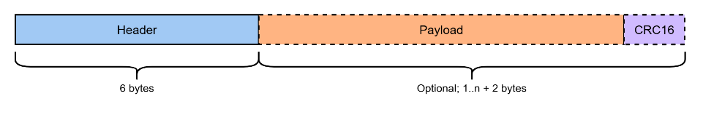
Request and response frames consist of a header along with an optional CRC-protected data payload.
Figure 5: Header overview
The header is always six bytes in length but has a slightly different structure in request and response frames.
Both headers include a CRC8 using the following parameters:
Polynomial | 0x97
Initial value | 0x00
XOR Out | 0x00
This CRC is also known as CRC-8-AUTOSAR.

3Request header
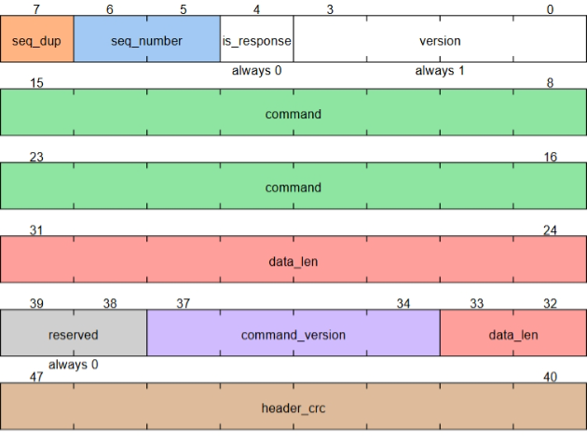
Figure 6: Request header structure
Field | Description
seq_dup | sequence duplicate flag; indicates re-transmission of previous request
seq_number | Sequence number; used by the host to correlate responses with requests
is_response | 0 for requests
version | Protocol structure version
command | command identifier
data_len | length of data associated with request, up to 1023 bytes
command_version | revision level of command
header_crc | CRC8 of header data

Response Header
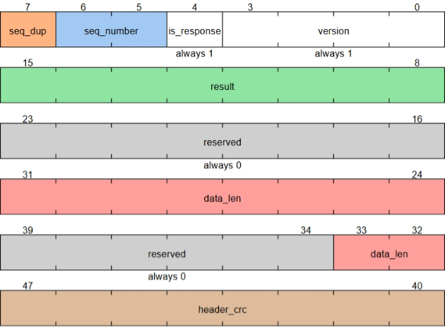
Figure 7: Response header structure
Field | Description
seq_dup | sequence duplicate flag; indicates re-transmission of previous response
seq_number | Sequence number; used by the host to correlate responses with requests
is_response | 1 for responses
version | Protocol structure version
result | Result code
data_len | length of data associated with response, up to 1023 bytes
header_crc | CRC8 of header data

Result codes
Code | Name | Description
0x00 | ECP_RES_SUCCESS | Request completed successfully
0x01 | ECP_RES_INVALID_COMMAND | Command not supported
0x02 | ECP_RES_ERROR | Request failed for other unspecified reason
0x03 | ECP_RES_INVALID_PARAM | Request contained invalid or out of range parameter
0x04 | ECP_RES_NOT_ALLOWED | Command not allowed in current state
0x05 | ECP_RES_UNSUPPORTED_CMD_VERSION | Unsupported command version
0x06 | ECP_RES_NOT_SUPPORTED | Command not implemented for provided parameters
0x07 | ECP_RES_BUSY | A conflicting command is still pending
0x08 | ECP_RES_TIMEOUT | Timeout while processing
0x09 | ECP_RES_OVERFLOW | Data overflow
0x0A | ECP_RES_INVALID_HEADER | Header has invalid or out of range data
0x0B | ECP_RES_REQUEST_TRUNCATED | Request was incomplete
0x0C | ECP_RES_RESPONSE_TOO_BIG | Response generates too much data
0x0D | ECP_RES_BUS_ERROR | General communication bus error
0x0E | ECP_RES_INVALID_HEADER_VERSION | Unsupported protocol version
0x0F | ECP_RES_INVALID_HEADER_CRC | Header CRC did not match
0x10 | ECP_RES_INVALID_DATA_CRC | Data CRC did not match
0x11 | ECP_RES_DUP_UNAVAILABLE | Unable to re-send response
0x12 | ECP_RES_STOPPED | Emergency stop. Reset required
0x13  …  0xFD | Reserved
0xFE | ECP_RES_IN_PROGRESS | Command accepted and is being processed
0xFF | ECP_RES_UNAVAILABLE | No result available

data: Payload
The payload contains one or more bytes as arguments or outputs of the command. The data field MUST NOT be included in the frame if data_length is zero.
All devices MUST support data payloads up to the maximum payload size.

data_crc: Payload CRC
This field is a 16-bit CRC over the payload data. The following parameters are used:
Polynomial | 0x1021
Initial value | 0xFFFF
XOR Out | 0x0000
This CRC is known as CRC16/CCITT-FALSE and is defined in ITU-T Recommendation V.41.
The data_crc field MUST only be included in the frame if data_length is non-zero. A frame with a data_length of zero and an included data_crc is not valid. ECPs SHOULD response to such messages with a result code of ECP_RES_OVERFLOW.
Devices MUST validate any received data against the data CRC and MUST reject any frames with invalid data CRCs.

Network layer
The ECP is always in one of two states: unconfigured or active. The ECP automatically enters the unconfigured state on power up. Upon successful initialization, the ECP moves to the active state. Command availability may vary by state.
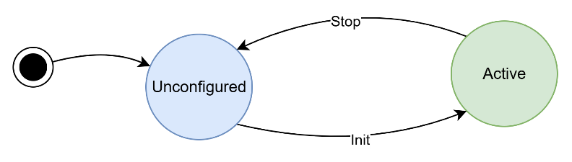

Unconfigured state
In the unconfigured state, If using I2C, the ECP uses a fixed 7-bit I2C address of 0x40. The ECP enters the unconfigured state immediately after powering up.
Some commands such as the I/O commands are not available in the unconfigured state because they require information that may not be available before enumeration.

Active state
The active state is the normal operational state of the ECP. If using I2C, in this state the ECP uses a 7-bit I2C address of 0x50 offset by a value specified by the host. The offset corresponds to the port index such that the first ECP uses 0x50, the second uses 0x51, and so on.
The ECP enters the active state after receiving a valid ECP_CMD_ENUM message. The process by which the host configures the ECPs is called enumeration.

Enumeration and addressing
Because each ECP in a device may have identical firmware and identical circuits, a method is needed to configure each ECP at runtime. The host enables each ECP in turn and using a known, default bus address configures the ECP and re-assigns it a unique address. The host then repeats the process for each ECP in turn. The host MAY automatically load or update the firmware of each ECP as part of the enumeration process.
🗒️NOTE
On a shared communication bus such as I2C, the host MUST have individual control of the reset signal of each ECP so that the host can address each ECP in sequence. Depending on the hardware design, additional I/O may be required such as bootloader control pins.
A flow chart depicting the enumeration process is shown below.
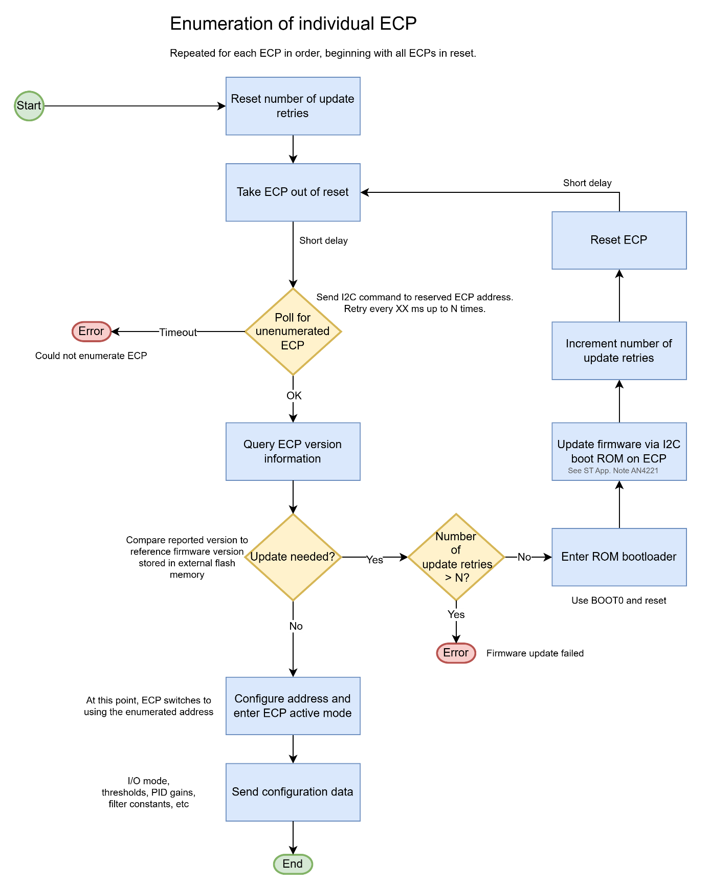
Figure 8: Enumeration of individual ECP

Application layer

Host operation
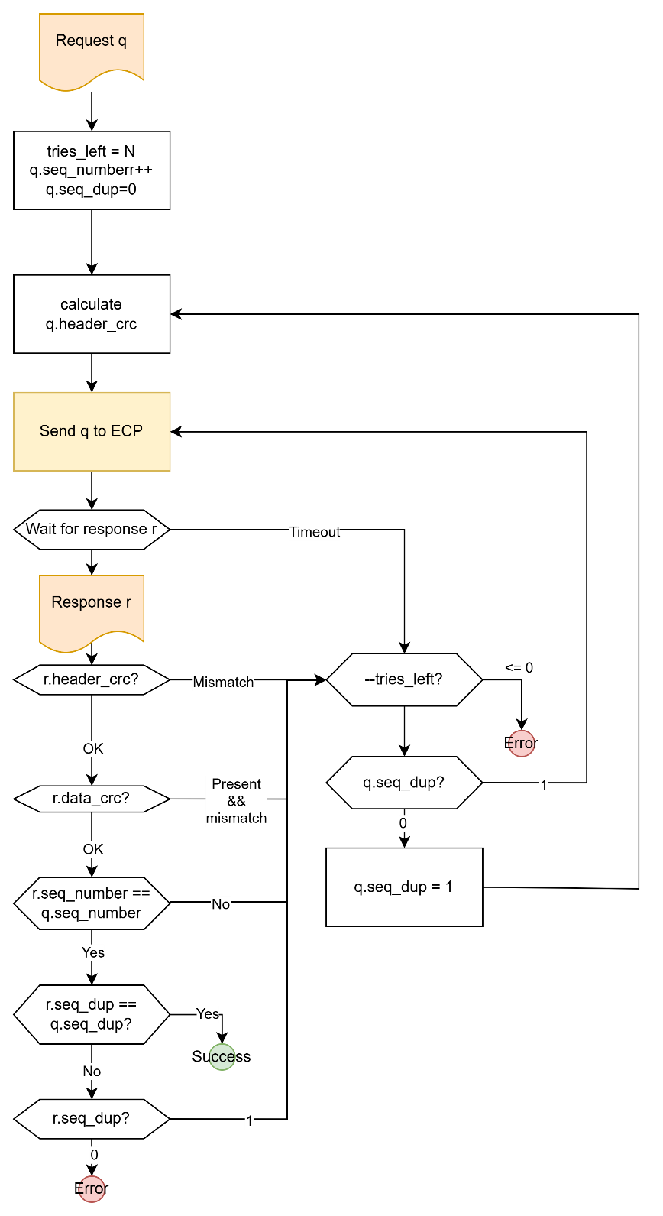
Figure 9: Host algorithm for transmitting requests

ECP operation
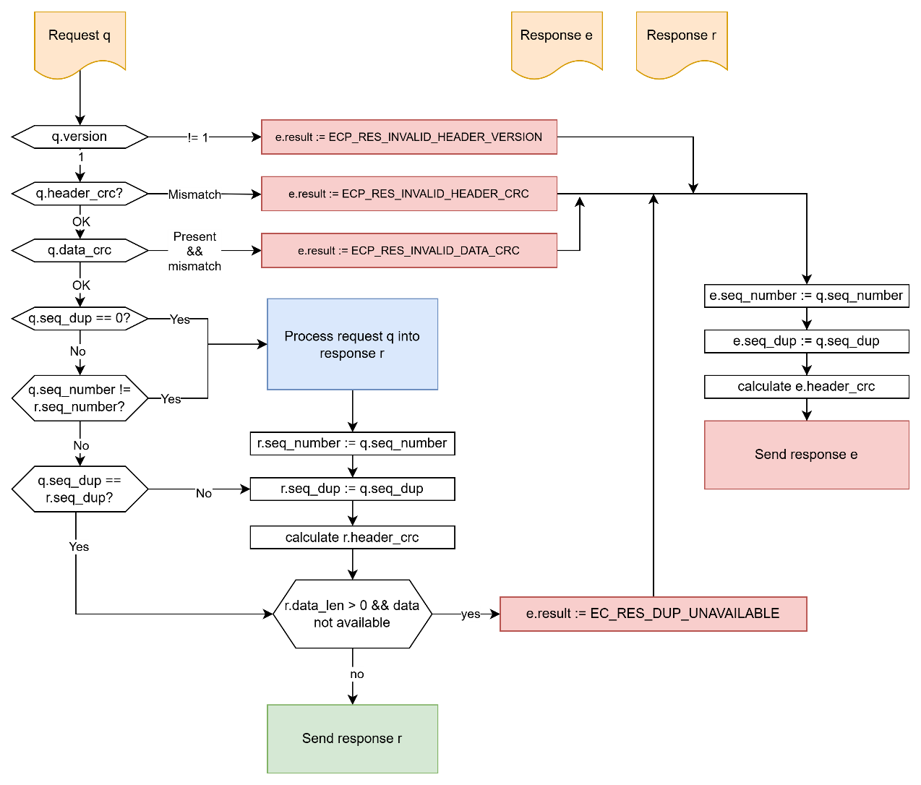
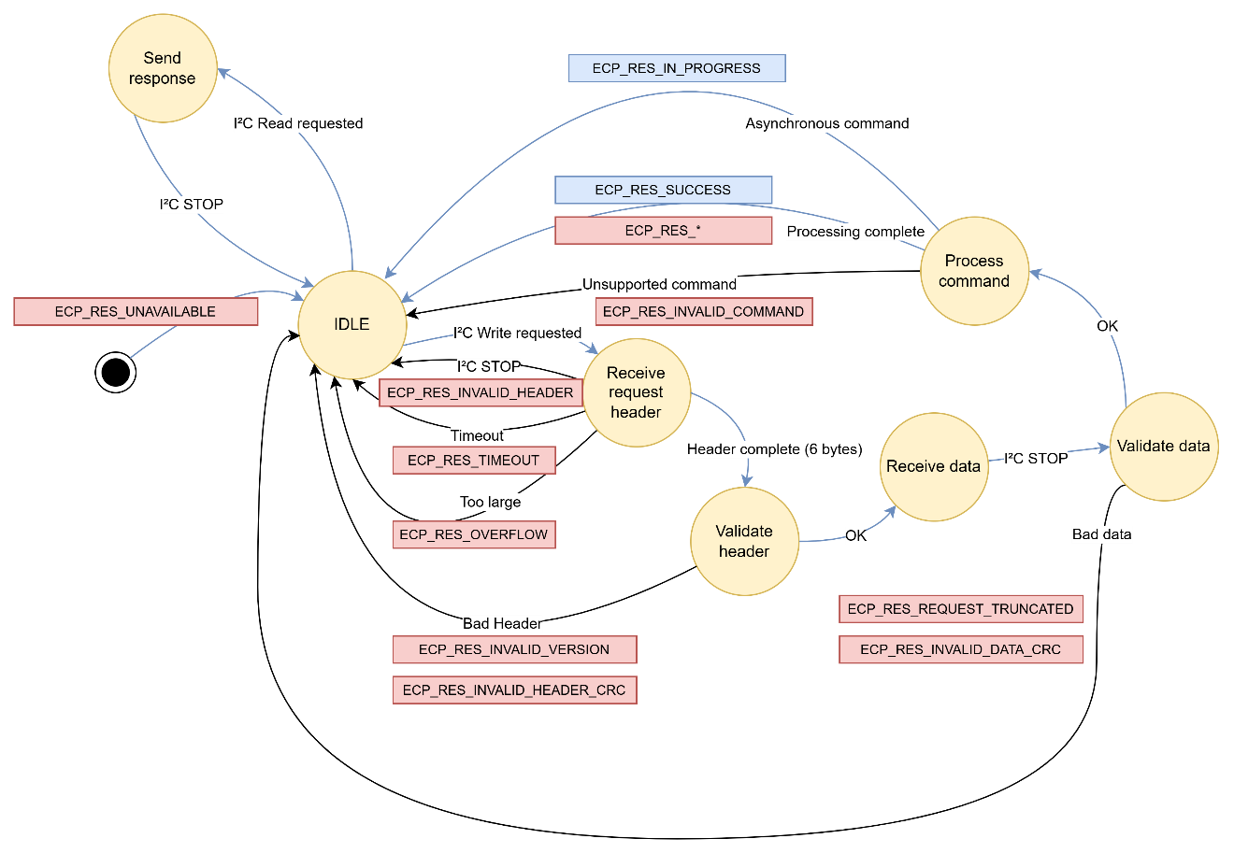
Figure 10: ECP algorithm for processing requests
Figure 11: ECP request processing state machine

Commands
All command identifiers are 16-bit values. Commands taking arguments or returning response data specify the structure of the payload data. If not specified, the command has no associated data.

Command 0x0000: ECP_CMD_PROTO_VERSION
This command gets the protocol version. This revision of the protocol always returns 2.
Command ID | 0x0000
Name | Protocol version
Command revision | 2
Request payload format | None
Response payload format | struct {  uint8_t versions;  uint16_t max_request_packet_size;  uint16_t max_response_packet_size;  uint16_t flags;  };
Required features | None
Availability | ✅Unconfigured  ✅Active
🗒️NOTE
“In-progress” support allows the host to query the status of long-running background tasks I2C-based ECPs SHOULD implement IN_PROGRESS_SUPPORTED.
Flag bit | Description
0 | IN_PROGRESS_SUPPORTED

Command 0x0001: ECP_CMD_IDENT
This command gets the software version information for the ECP.
Command ID | 0x0001
Name | Software Identification
Command revision | 1
Request payload format | struct {  uint8_t major;  uint8_t minor;  uint16_t patch;  uint32_t build;  uint8_t sw_part_number[16];  };
Response payload format | struct {  uint8_t major;  uint8_t minor;  uint16_t patch;  uint32_t build;  uint8_t sw_part_number[16];  };
Required features | None
Availability | ✅Unconfigured  ✅Active

Command 0x0002: ECP_CMD_ENUM
This command instructs the ECP to set its address and enter active mode. The ECP uses the type and revision fields to aid hardware configuration.
Command ID | 0x0002
Name | Enumerate
Command revision | 2
Request payload format | struct {  uint8_t offset;  uint8_t ecp_type;  uint8_t ecp_revision;  };
Response payload format | None
Required features | None
Availability | ✅Unconfigured  ❌Active

# | ECP Type
1 | ECP_TYPE_DO_DI_5A
2 | ECP_TYPE_DO_DI_13A
3 | ECP_TYPE_DOPLUS_DI
4 | ECP_TYPE_ADI

Command 0x0003: ECP_CMD_HELLO
This command verifies that the ECP is responsive to commands. The ECP SHALL return in_data + 0x01020304.
Command ID | 0x0003
Name | Hello
Command revision | 1
Request payload format | struct {  uint32_t in_data;  };
Response payload format | struct {  uint32_t out_data;  };
Required features | None
Availability | ✅Unconfigured  ✅Active

Command 0x0004: ECP_CMD_ECHO
This command is like ECP_CMD_HELLO, but supports arbitrary data lengths. Unlike ECP_CMD_HELLO, the ECP returns unmodified data from the request. This is useful for stress testing the ECP communication bus at varying packet lengths.
Command ID | 0x0004
Name | Echo
Command revision | 1
Request payload format | struct {  uint8_t data[];  };
Response payload format | struct {  uint8_t data[];  };
Required features | None
Availability | ✅Unconfigured  ✅Active

Command 0x0005: ECP_CMD_REBOOT
This command restarts the ECP immediately after the response is read. The ECP will need to be re-enumerated, and all I/O channels will need to be re-configured.
Command ID | 0x0005
Name | Reboot
Command revision | 1
Request payload format | None
Response payload format | None
Required features | None
Availability | ✅Unconfigured  ❌Active

Command 0x0006: ECP_CMD_FEATURES
This command returns the supported features. Feature support is indicated by setting the corresponding bit. See Features for details.
Command ID | 0x0006
Name | Get supported features
Command revision | 1
Request payload format | None
Response payload format | struct {  uint32_t flags;  };
Required features | None
Availability | ✅Unconfigured  ✅Active

Command 0x0007: ECP_CMD_DEVICE_EVENT
Query and configure device events. Device events can be used by the host to quickly check for what needs to be serviced after the ECP asserts the interrupt GPIO.
Value | Operation
0 | ECP_DEVICE_EVENT_OP_GET_CURRENT_EVENTS
1 | ECP_DEVICE_EVENT_OP_GET_ENABLED_EVENTS
2 | ECP_DEVICE_EVENT_OP_SET_ENABLED_EVENTS

Bit | Event | Description | Default
0 | ECP_DEVICE_EVENT_BOOT | Set on boot. Can be used to detect software restarts.
1 | ECP_DEVICE_EVENT_THERMAL | Set when temperature threshold exceeded | X
2 | ECP_DEVICE_EVENT_IO_FAULT | Set when one or more channels detects a fault | X

The status of all events is reflected in the value of event_mask, but only enabled events trigger the interrupt GPIO output.
Command ID | 0x0007
Name | Device Events
Command revision | 1
Request payload format | struct {  uint32_t event_mask;  uint8_t operation;  };
Response payload format | struct {  uint32_t event_mask;  };
Required features | ECP_FEATURE_DEVICE_EVENT
Availability | ✅Unconfigured  ✅Active

Command 0x0008: ECP_CMD_ESTOP
This command immediately returns all I/O to a safe state and enters the unconfigured state. This command has no effect when the ECP is already in the unconfigured state.
❗ IMPORTANT
If multiple ECPs are sent the ESTOP command on a shared bus such as I2C, the only reliable way to recover is to re-enumerate all ECPs.
Command ID | 0x0008
Name | Emergency stop
Command revision | 1
Request payload format | None
Response payload format | None
Required features | None
Availability | ✅Unconfigured  ✅Active

Command 0x0009: ECP_CMD_BOOT_JUMP
This command instructs the ECP to enter the bootloader immediately after the response is read. The ECP will no longer be available until it is restarted.
Command ID | 0x0009
Name | Jump to bootloader
Command revision | 1
Request payload format | None
Response payload format | None
Required features | None
Availability | ✅Unconfigured  ❌Active

Command 0x1000: ECP_CMD_IO_READ
Get the value of an I/O channel.
Command ID | 0x1000
Name | Get channel state
Command revision | 2
Request payload format | struct {  uint8_t ch;  }
Response payload format | struct {  uint8_t ch;  uint8_t mode;  uint32_t raw;  int32_t scaled;  int32_t voltage; // feedback mV, or -1  int32_t current; // feedback mA, or -1  int32_t temperature; // 0.001 °C,  // or -1 if not equipped  uint8_t fault_status;  uin8t_t hb_direction;  uin8t_t flags;  }
Required features | ECP_FEATURE_CH_IO
Availability | ❌Unconfigured  ✅Active
The raw and scaled data depends on the active mode:
Mode | Raw | Scaled
Disable | -1 | -1
PWMOUT | Scaled, ramped duty cycle (MIN – MAX) | Commanded duty cycle (0-10000)
PWMIOUT | Commanded duty cycle | Setpoint (mA)
DIN_POS | 0/1 | Same as raw
FREQIN_POS | Input freq. (mHz) | Measured duty cycle (0-10000)
COUNT_POS | Counts (+ only) | Same as raw
ENCODER_POS | Counts (+/-) | Same as raw
DIN_GND | 0/1 | Same as raw
FREQIN_GND | Input freq. (mHz) | Measured duty cycle (0-10000)
COUNT_GND | Counts (+ only) | Same as raw
ENCODER_GND | Counts (+/-) | Same as raw
AIN_0_5_V | ADC counts | Voltage (mV)
AIN_0_10_V | ADC counts | Voltage (mV)
AIN_0_32_V | ADC counts | Voltage (mV)
AIN_4_20_MA | ADC counts | Current (μA)
R_IN | ADC counts | Resistance (mΩ)

The flags field is encoded as follows:
Bit | Name | Description
7:6 | Channel Status | 00: Inactive  01: Active  02: Error/Fault  03: Not available
5:4 | Sensor Power Status | 00: Inactive  01: Active  02: Error/Fault  03: Not available
3:2 | Soft switch status | 00: Inactive  01: Active  02: Error/Fault  03: Not available
1 | Paused | 0: Not paused  1: Paused
0 | Reserved | Always 0

Command 0x1001: ECP_CMD_IO_WRITE
Set the value of an output channel. Interpretation of value depends on the channel type and configured mode.
Command ID | 0x1001
Name | Write channel state
Command revision | 1
Request payload format | struct {  uint8_t ch;  int32_t value;  }
Response payload format | None
Required features | ECP_FEATURE_CH_IO
Availability | ❌Unconfigured  ✅Active

Mode | Value | Units
Disable | Ignored
PWMOUT | Commanded duty cycle | 0 – 10000
PWMIOUT | Setpoint | mA
DIN_POS | Sensor power enable
FREQIN_POS | Sensor power enable
COUNT_POS | Sensor power enable
ENCODER_POS | Sensor power enable
DIN_GND | Sensor power enable
FREQIN_GND | Sensor power enable
COUNT_GND | Sensor power enable
ENCODER_GND | Sensor power enable
AIN_0_5_V | Sensor power enable
AIN_0_10_V | Sensor power enable
AIN_0_32_V | Sensor power enable
AIN_4_20_MA | Sensor power enable
R_IN | Sensor power enable

Command 0x1002: ECP_CMD_IO_GET_ATTRIB
Get an attribute of an I/O channel. Attribute identifiers are defined by the DPUnity port API. Interpretation of the value is attribute specific.
Command ID | 0x1002
Name | Get channel attribute
Command revision | 1
Request payload format | struct {  uint8_t ch;  uint8_t attrib_id;  };
Response payload format | struct {  uint8_t ch;  uint8_t attrib_id;  uint32_t value;  };
Required features | ECP_FEATURE_CH_IO
Availability | ❌Unconfigured  ✅Active

Command 0x1003: ECP_CMD_IO_SET_ATTRIB
Set an attribute of an I/O channel Attribute identifiers are defined by the DPUnity port API. Interpretation of the value is attribute specific.
Command ID | 0x1003
Name | Set channel attribute
Command revision | 1
Request payload format | struct {  uint8_t ch;  uint8_t attrib_id;  uint32_t value;  };
Response payload format | None
Required features | ECP_FEATURE_CH_IO
Availability | ❌Unconfigured  ✅Active

Command 0x1100: ECP_CMD_LED_COLOR
Set the color(s) of an LED.
Command ID | 0x1100
Name | Set LED color
Command revision | 1
Request payload format | struct {  uint8_t led; // LED index  uint8_t color_count; // 3 for RGB  uint8_t colors[]; // color intensity, 0-255  };
Response payload format | None
Required features | ECP_FEATURE_LED
Availability | ❌Unconfigured  ✅Active

Command 0x1101: ECP_CMD_LED_BRIGHTNESS
Set the brightness of an LED.
Command ID | 0x1101
Name | Set LED brightness
Command revision | 1
Request payload format | struct {  uint8_t led; // LED index (0xFF for all)  uint8_t brightness; // overall brightness, 0-255  };
Response payload format | None
Required features | ECP_FEATURE_LED
Availability | ❌Unconfigured  ✅Active

Command 0x1200: ECP_CMD_GPIO_CONFIG
Configure available GPIO. The mask field indicates which bits of the direction field should be changed. Use a mask of 0x0000 to retrieve the current configuration without modifying it. Use a mask of 0xFFFF to configure all GPIO.
Default GPIO configuration depends on ECP implementation. GPIO mapping and availability depends on ECP implementation.
The ECP SHALL ignore attempts to configure unsupported GPIO.
Command ID | 0x1200
Name | Configure GPIO
Command revision | 1
Request payload format | struct {  uint16_t direction; // 0: output, 1: input  uint16_t mask;  };
Response payload format | struct {  uint16_t direction; // 0: output, 1: input  };
Required features | ECP_FEATURE_GPIO
Availability | ✅Unconfigured  ✅Active

Command 0x1201: ECP_CMD_GPIO
Get/set available GPIO. The mask field indicates which bits of the outputs field should be changed. Use a mask of 0x0000 to retrieve the current values without modifying them. Use a mask of 0xFFFF to write all outputs.
Default GPIO configuration depends on ECP implementation. GPIO mapping and availability depends on ECP implementation.
The ECP SHALL ignore attempts to set an unsupported GPIO. The ECP SHALL ignore attempts to set GPIO configured as inputs.
Command ID | 0x1201
Name | Get/Set GPIO
Command revision | 1
Request payload format | struct {  uint16_t outputs;  uint16_t mask;  };
Response payload format | struct {  uint16_t inputs;  };
Required features | ECP_FEATURE_GPIO
Availability | ✅Unconfigured  ✅Active

Command 0xFF00: ECP_CMD_PEEK
This command allows the host to read arbitrary data from the RAM of the ECP for debugging purposes. The ECP MAY restrict access to certain memory regions. The ECP MAY require specific byte alignment. Certain error conditions might cause the ECP to reset.
❗ IMPORTANT
This command has security implications.

Command ID | 0xFF00
Name | Peek, memory read
Command revision | 1
Request payload format | struct {  uint32_t address;  uint16_t count;  };
Response payload format | struct {  uint8_t data[];  };
Required features | ECP_FEATURE_PEEK_POKE
Availability | ✅Unconfigured  ✅Active

Command 0xFF01: ECP_CMD_POKE
This command allows the host to write arbitrary data into the RAM of the ECP for debugging purposes. The ECP MAY restrict access to certain memory regions. The ECP MAY require specific byte alignment. Certain error conditions might cause the ECP to reset.
❗ IMPORTANT
This command has security implications.

Command ID | 0xFF01
Name | Poke, memory write
Command revision | 1
Request payload format | struct {  uint32_t address;  uint16_t count;  uint8_t data[];  };
Response payload format | None
Required features | ECP_FEATURE_PEEK_POKE
Availability | ✅Unconfigured  ✅Active

Command 0xFF02: ECP_CMD_COMM_STATS
This command returns statistics related to the ECP communication interface.
Command ID | 0xFF02
Name | Communication statistics
Command revision | 1
Request payload format | None
Response payload format | struct {  uint32_t request_count;  uint32_t error_count;  uint32_t dup_count;  uint32_t request_bytes;  uint32_t response_bytes;  };
Required features | ECP_FEATURE_COMM_STATS
Availability | ✅Unconfigured  ✅Active

Command 0xFF03: ECP_CMD_UPTIME
This command returns the uptime of the ECP and the reset cause. Implementations SHOULD identify the cause of the last reset. Implementations MUST use a reset reason of 0 (UNKNOWN) if the cause cannot be determined.
Value | Reset reason
0 | UNKNOWN
1 | POWER
2 | BROWNOUT
3 | TRAP
4 | EXTERNAL
5 | SOFTWARE
6 | WATCHDOG
7 | OTHER

Command ID | 0xFF03
Name | Uptime
Command revision | 1
Request payload format | None
Response payload format | struct {  uint32_t uptime_ms;  uint8_t reset_reason;  };
Required features | None
Availability | ✅Unconfigured  ✅Active

Features
This document describes all currently defined messages, but individual ECP implementations may not implement all features. Reasons for not supporting a feature include memory constraints or features intended for non-production testing and development.
Bit | Name | Description
0 | ECP_FEATURE_CH_IO | DPUnity port channel I/O
1 | ECP_FEATURE_PEEK_POKE | Direct memory access
2 | ECP_FEATURE_GPIO | Read/write individual I/O pins
3 | ECP_FEATURE_DEVICE_EVENT | Events from ECP to host
4 | ECP_FEATURE_COMM_STATS | Keep track of ECP communication errors
5 | ECP_FEATURE_LED | RGB LED control
6..31 | Reserved

ECP_FEATURE_CH_IO
This feature supports the use of the DPUnity port I/O API. Nearly all ECPs will implement this feature.

ECP_FEATURE_PEEK_POKE
This feature allows direct access to memory on the ECP and thus is not intended to be enabled in production builds. It is useful for development and troubleshooting in a lab environment.

ECP_FEATURE_GPIO
This feature allows control of specific pins of the ECP that may not be associated with the port I/O. This feature is mostly intended for debugging, but could also be used by the host to read configuration pins or perform other functions.

ECP_FEATURE_DEVICE_EVENT
This feature allows the host to monitor one or more events that happen on the ECP. This is used by the host to identify what needs servicing after a shared interrupt is sent by an ECP.

ECP_FEATURE_COMM_STATS
This feature allows tracking of communication errors.

ECP_FEATURE_LED
This feature supports control of user-visible LED indicators.

Reference

DPPort attributes
NOTE: The C enumeration for each value below is prefixed with PORT_CH_ATTRIB_.
# | Name | Description
0 | MODE | I/O channel mode
1 | PID_TIME | PID loop period, in ms
2 | PID_KP | PID proportional gain constant
3 | PID_KI | PID integral gain constant
4 | PID_KD | PID derivative gain constant
5 | PWM_MIN_DUTY | Minimum PWM output duty cycle
6 | PWM_MAX_DUTY | Maximum PWM output duty cycle
7 | PWM_RAMP_TIME_UP | Time to ramp from minimum duty to maximum duty
8 | PWM_RAMP_TIME_DOWN | Time to ramp from maximum duty to minimum duty
9 | OUTPUT_CURRENT_SOFT_LIMIT | Threshold for i2t letthrough
10 | OUTPUT_CURRENT_TRIP_TIME | Trip time for i2c letthrough monitoring
11 | OUTPUT_OVERCURRENT_REACTION | Determines behavior when letthrough limit is reached
12 | OUTPUT_CURRENT_LIMIT_MAX_RETRIES | Number of times to allow retrying
13 | COUNTER_EN | Deprecated
14 | COUNTER_ENABLE_OUT | Deprecated
15 | COUNTER_OVERFLOW_ENABLE | If set, the counter will “overflow” back to zero when set point is reached.
16 | COUNTER_SET_POINT | Maximum value for counter before saturation or overflow
17 | HBRIDGE_INVERT_DIRECTION | Change sense of current flow in h-bridge outputs
18 | SENSOR_POWER_BOOT_ENABLE | Not used on ECP
19 | SENSOR_POWER_VOLTAGE_SELECT | Selects sensor power output (5 V or Vbat)
20 | DIGIN_ANALOG_THRESHOLD_LOW | Threshold for configurable digital inputs, including frequency
21 | DIGIN_ANALOG_THRESHOLD_HIGH | Threshold for configurable digital inputs, including frequency
22 | ANALOG_INPUT_FILTER_CONSTANT | Filter constant for analog inputs and output current feedback
23 | DISABLE_CURRENT_CHOPPING | Disables current chopping on supported outputs

Result code equivalent POSIX errno
The table below maps ECP result codes into system error numbers based on The Open Group Base Specifications Issue 8, 2024 edition (IEEE 1003.1-2024) – also known as POSIX.1-2024. The system error numbers are found in the errno.h C header file.
Result code | POSIX Error Number (errno)
ECP_RES_SUCCESS | 0
ECP_RES_INVALID_COMMAND | -EPROTO
ECP_RES_ERROR | -EIO
ECP_RES_INVALID_PARAM | -EINVAL
ECP_RES_NOT_ALLOWED | -EPERM
ECP_RES_UNSUPPORTED_CMD_VERSION | -EPROTO
ECP_RES_NOT_SUPPORTED | -ENOTSUP
ECP_RES_BUSY | -EBUSY
ECP_RES_TIMEOUT | -ETIMEDOUT
ECP_RES_OVERFLOW | -EOVERFLOW
ECP_RES_INVALID_HEADER | -EIO
ECP_RES_REQUEST_TRUNCATED | -EPROTO
ECP_RES_RESPONSE_TOO_BIG | -E2BIG
ECP_RES_BUS_ERROR | -EFAULT
ECP_RES_INVALID_HEADER_CRC | -EIO
ECP_RES_INVALID_DATA_CRC | -EIO
ECP_RES_DUP_UNAVAILABLE | -ENOMSG
ECP_RES_STOPPED | -EHOSTDOWN
ECP_RES_IN_PROGRESS | -EINPROGRESS
ECP_RES_UNAVAILABLE | -ENOENT

Revision History

